Template for Evidence(s)
UI GreenMetric Questionnaire

University : ...
Country : ...
Web Address : …

[5] Transportation (TR)
SAMPLE
[5.16] Pedestrian Path Policy on Campus

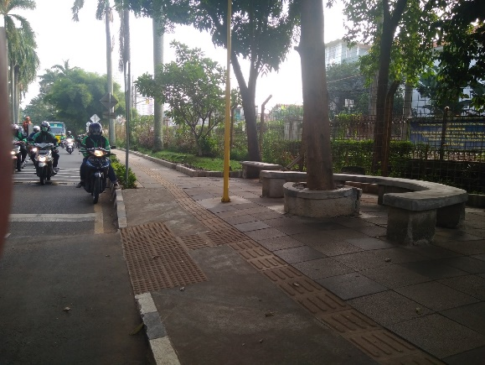 | 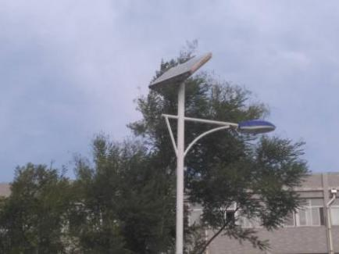
Example of pedestrian path (Universitas Indonesia, Indonesia) | Example of pedestrian path (Shandong Normal University - Lishan College, China)

Description:
(Please describe pedestrian path policy on your campus. The following is an example of the description. You can describe more related items if needed.)

- Separator between road for vehicle and pedestrian path.
- Ramps and guiding blocks which have suitable design for pedestrian having physical disabilities.
- Street lamp for pedestrian in night. Lishan College has 200 solar street lamps, which control the solar street lights automatically through the intensity of light.

Additional evidence link (i.e., for videos, more images, or other files that are not included in this file):

